60s and 70s Social Movements

Part I: President Johnson’s Great Society

Johnson rises to Office of the President
Lyndon B. Johnson was Vice President under John F. Kennedy. On Nov. 23, 1963, President Kennedy was in Dallas, Texas, to kick off his re-election campaign for the election in 1964. While driving through downtown Dallas in a convertible limousine, JFK was shot by Lee Harvey Oswald. The assassination shocked the nation and elevated Johnson (known by his initials LBJ) to the highest office in the land.

The Great Society
Johnson is probably best known for being the president who committed the United States fully to the war in Vietnam. In doing that he had little choice due to the fact that communist North Vietnam invaded democratic South Vietnam (sounds like we’re heard this situation before, doesn’t it?). But Vietnam in-depth is our next unit, so back to Johnson’s domestic agenda.
Johnson’s Great Society is seen as an extension of FDR’s New Deal in that it was aimed at helping the jobless and the less fortunate. He is the president who signed into law both the Civil Rights Act of 1964 and Voting Rights Act of 1965 to increase protection of rights for African Americans and other minorities.
His big goal was to eliminate poverty. LBJ was a different president than most – he wasn’t born to wealth and privilege. He understood poverty and the struggles that poor people have because he grew up poor. One of his first actions was to pass the Equal Opportunities Act (EOA) that put nearly $1 billion into youth education, job training and small business loans.

How the Great Society helped
All the programs of the Great Society were meant to eliminate poverty and covered a wide-range of issues, from healthcare to education to housing and job training. Two of the main programs had to do with healthcare and both still exist today: Medicare and Medicaid. These programs provide government-supported healthcare for citizens who qualify through their low-income status. Medicare is for elderly (old) people while Medicaid is available to citizens of any age who have a qualifying low income. The one to keep them separated in your head is to realize that Medicare ends with the letter “e” and it’s available to the elderly, which begins with the letter “e”.

Education programs that were created were Head Start and Upward Bound. Both still exist today. Head Start is for preschoolers who are economically disadvantage (poor). These kids often start school significantly behind their peers in academics. They don’t know their ABCs or how to count. Some have never even held a crayon. So they’ll spend entire school life trying to catch up. These students often become discouraged by 3rd or 4th grade and then “give up” and just come to school for something to do or someplace to go. Head Start provides free pre-kindergarten for these kids to make sure they start kindergarten on a relatively level playing field.
Upward Bound is a program for high school students who are economically disadvantaged who want to go to college. It provides tutoring services as well as financial assistance for college.
Both of these programs operate on the same basic principle – the only way to break the cycle of poverty is through education so you can get a good job and therefore make enough money to not be in poverty anymore. One other education program was the Higher Education Act which funded scholarships and low-interest loans for college students.

The Department of Housing and Urban Development (HUD) built “Model Cities” that included over 240,000 units of low-rent public housing in urban areas. It also provided money for low- and moderate-income families to be able to afford better housing. At the head of this new department was Robert Weaver, the first black member of a president’s cabinet in United States history.

The Great Society did not eliminate poverty, but did a lot to alleviate it. Poverty rates in America dropped from 21 percent of the population in 1962 to 11 percent in 1973. LBJ did more than any president, aside from FDR, in the last 100 years to help the low-income members of United States society.

Part II: Student/Youth Movement and Counterculture

Roots of the Youth Movement
The youth are rebelling against their parents. These kids grew up during the 1950s with the threat of nuclear war hanging over their heads. These kids are those kids during the “baby boom” of the 1950s. The “Beat Movement” started in 50s, characterized by literature blasting the 1950s attitude of conformity. Now these kids are being exposed to it in college. This generation is the first “big” college generation.

The main beliefs of these young people is the reject the “Establishment”, in other words, adult society. They don’t want to be told what to do, or live by the rules made, by people who have created a world in which nuclear war is a possibility, or started a war in Vietnam that these young people have to fight. Basically, if you’re over 30, they reject you and what you stand for. These young people also largely reject materialism, or the accumulation of personal belongings. They want to share equally (no wonder many people thought hippies were communists!).

The Counterculture Movement (Hippies!)
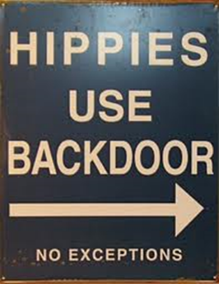
Hippies are the most commonly known part of counterculture youth movement. They believed in sex (with everybody), drugs (mind-altering as well as marijuana) and rock and roll (Hendrix, Fleetwood Mac, Grateful Dead). It was kind of a self-defeating belief though. It was not built to last because of the health effects of free love and heavy drug use. Plus, eventually, most realize they have to get a job to support themselves, which is very anti-hippie because, you know, working for The Man (or Establishment). Very uncool, maaaaaannn. People get to a certain age, realize they don’t have much to speak of, and decide the lifestyle is no longer for them.

Many hippies lived in small, self-sufficient communities, called communes. In these communities, most everything was shared equally, including possessions, sexual partners and work responsibilities. But largely, there were no leaders, so most failed pretty quickly due to the fact that they could not provide for their residents.

Within the drug culture, the most popular were acid (LSD) and pot. Timothy Leary, a psychology professor at Harvard, promoted LSD use and actually got fired from his teaching position for doing LSD experiments using Harvard students. The biggest moment of the counterculture movement was, of course, the Woodstock Music and Arts Festival in the summer of 1969 near Woodstock, N.Y.

Impact of Counterculture
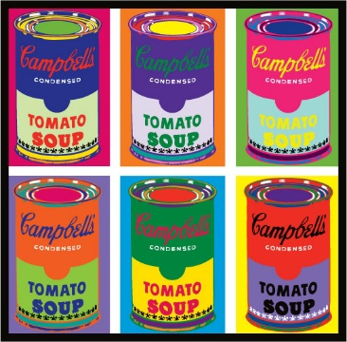
The longest-lasting effect is in fashion, art and music. Tie-dye fashion is still popular. Military fatigues became popular. This is because they were about as generic and non-materialistic (name-brand) as could you could get. The fatigues popularity is ironic though, because they were anti-war and this was in the middle of the Vietnam war. Long hair became in fashion, too, because it was rebellious. In art, psychodelic pop art was big things. See Andy Warhol’s work. You’ve probably seen the Campbell’s Soup painting.

Part III: The Feminist Movement

Fighting for Women’s Rights
The Feminist Movement started because women were being discriminated against in society and in the work place. They were seen as the weaker, lesser sex. Women began by fighting for equal pay, equal opportunities, equal protection under the law. In the 1960s, if a man made $1 doing a job, women were getting paid just 59-cents for the same job. To address this disparity, the Equal Pay Act was pushed through requiring equal pay for equal work.

Title VII (7) of the Civil Rights Act of 1964 outlawed gender discrimination in the workplace. So jobs would not be able to deny hiring you because you were a woman. This extends the protection of the CRA of 1964 from racial to include gender discrimination.

The Feminine Mystique was the best-selling book by Betty Friedan that convinced many women to join the feminist cause. In it, she interviewed a number of women she graduated college with 10 years before. It started out as a “where are they now” story for the college’s alumni magazine. But what she found was odd: these women who went to college, married well, and seemed to have the perfect lives with a nice house, car, kids, etc., were extremely unhappy. They felt unfulfilled by their housewife life. They were educated and qualified to do more, but weren’t. It was a wake-up call for women to join feminist movement.

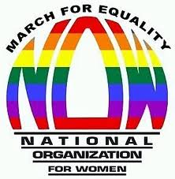
During the 1960s, a women’s rights organization, NOW (National Organization for Women), was formed. It wanted women to have a full, equal partnership with men in society. It called for more educational opportunities for women and aid in the workplace for better pay and childcare.

Some women rebelled against this movement because they liked the traditional role of women as the housewife and homemaker. They felt these feminists were attacking their way of life, saying that it was a waste. Others didn’t support NOW because NOW supported a women’s right to choose abortion and many women were anti-abortion (pro-life).

Success and Failures of the Feminist Movement
Title IX (9) of the Civil Rights Act of 1964 says girls need to be given same opportunities in public education as boys. Originally it was aimed at academics, but most commonly applied today to athletics (can’t have more boys sports than girls sports). Prior to Title IX, girls in school were often not allowed to progress in math and science beyond basic classes, so no geometry, chemistry, calculus or physics. Instead, they had to take what were called home economics courses like cooking, cleaning and child care. This would prevent them from getting education in high school good enough to go to college and become professionals in things other than secretarial or teaching jobs. Title IX gave girls access to these educational opportunities.

Women also got a win in the Supreme Court case of Roe v. Wade. In the case, a woman who did not want to have a baby was not allowed to have an abortion according to Texas state law. She sued for the right to terminate the pregnancy, saying that she had the right to do what she wanted with her body, including undergoing a medical procedure to end her pregnancy. She said it was her 14th Amendment right. The Supreme Court agreed with her, to an extent. In its ground-breaking ruling, the Court decided a women did have a right to an abortion under the following three circumstances:

- No state laws could outlaw abortion in the first trimester (three months) of a pregnancy.
- In the second trimester (months 4-6), states CAN outlaw abortion. HOWEVER, if the pregnancy is deemed a danger to the health of the woman, she CAN STILL abort.
- In the last trimester, states CAN outlaw abortion to protect the child as they are deemed capable of living outside the womb.
But it is important to realize that all these decisions under 2 and 3 are made at the STATE level. The only nationwide law on abortion is what is stated under #1 above.

Ultimately, the feminist movement failed to gain full equality for women. They tried through an Equal Rights Amendment which would have meant that all people are exactly the same in eyes of law (no gender/race, etc.), but it was not approved by enough states to add it to the Constitution. Women and minorities worked against its passage because had it passed, people would have no longer been able to bring lawsuits for discrimination, sexual harassment, etc., because the legal system wouldn’t recognize those charges because all people would be considered unisex/uniracial, etc.

Part IV: The Hispanic-American Movement

The Roots of the Movement
Just like African Americans and women, Hispanic Americans faced challenges socially, politically and economically. They were hoping to get 14th Amendment protections extended to them as well. But they had challenges that others didn’t – largely it was difficult for them to unify because within the Hispanic population, there are people from different regions, different status within America and different concerns.

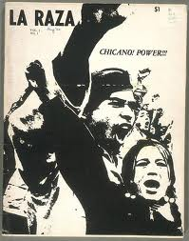
There are five main subgroups of Hispanics in the United States: Mexican-Americans, Puerto Ricans, Cubans, Central Americans and South Americans. Puerto Ricans hold a better position because Puerto Rico is an American territory, so they are born citizens. Therefore, citizenship is not a concern for them like it is for others. Cubans also get different treatment due to Cuba’s status as a communist country and our desire to help people trying to escape the oppressive dictatorship. So if a Cuban refugee manages to make it onto dry land anywhere in the United States, they automatically get to stay and become a LEGAL alien. For other Hispanics trying to come here, and obtain citizenship, things are much more difficult.

Due to these differences, it has been difficult for Hispanics to gain much political power because of the different concerns and desires of the subgroups. However, a political group emerged in the 1960s and 70s called La Raza Unida that managed some unity, but got very little actually accomplished.

Main Issues
The biggest issues facing the Hispanic American population were the bracero program, illegals and the border, services for the undocumented aliens (illegals) and the challenge for legal immigrants, and US citizens of Hispanic decent, finding jobs.

The bracero program was started in World War II when Mexican labor was needed, especially in agriculture in the Southwestern United States. It was a work program that allowed Mexicans to come to America and work, but they were taken advantage of financially. The goal of the movement in this area was to allow for a path to citizenship, and better pay and treatment of workers. Another huge issue was securing the borders to prevent illegal immigration, as well as how illegals who make it to America are treated. Many Hispanics wanted social services like education and healthcare to be available for those people. The theory behind this is that if they are here, they should become productive members of society and if the country doesn’t give them education and good health, they will turn to life of desperation and crime. Some people buy that theory and others say if they aren’t here legally, they should get no help from our government.

Jobs, of course, are a huge issue. It became a big issue for those Hispanics who were born here, and therefore were citizens, or those who came legally. Most legal immigrants don’t approve of illegals, especially back in the 1960s and 1970s because a lot of employers stopped hiring ANY Hispanics because the government starting handing out big fines against businesses who hired undocumented workers. So employers would rather play it safe and hire no Hispanics than run the risk of hiring one they thought was legal only to find out they were under a stolen identity. This made it very difficult for Hispanics to find work.

Economic and Education Issues
For those who did have a job, most were being taken advantage of by employers with very low wages and poor working conditions. A vast majority of Hispanics in the Southwest United States (New Mexico, Arizona, Nevada, California) were farmworkers who worked for next to nothing pay-wise, 12-14 hour days and no benefits, such as healthcare and insurance.

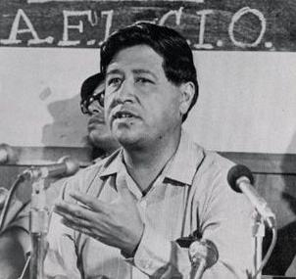
Cesar Chavez was a labor leader in California who became the face of the Hispanic Movement. Many call him the MLK of the movement because he promoted non-violent, passive resistance and boycotts. He organized the United Farm Workers Organizing Committee (UFWOC), most famously grape workers, to demand better pay and conditions and was successful. There was a large boycott in the western states led by Chavez that resulted in large gains for pay and working conditions.

Educationally, Hispanics fought for classes in public schools to be provided in Spanish and to have schools recognize cultural heritage. This resulted in the Bilingual Education Act. It requires public schools to provide, at minimum, accommodations to assist in their learning in their primary language.

The Biggest Issue: Minority Status
Biggest goal for the Latino community was to be legally recognized as a minority. Up until the 1970s, Hispanics were legally considered white. This prevented them from filing lawsuits based on racial discrimination, so employers and others were free to discriminate, knowing they couldn’t be sued. In other words, Hispanics were not covered by the provisions of the Civil Rights Act of 1964. But in 1968, they got legal recognition which allowed them to sue for discrimination, so saw less discrimination.

