November 10, 2014

Dear Parents & Guardians:

The School District of Indian River County (SDIRC) is committed to providing students with the digital tools and applications necessary to be successful in a 21st Century classroom. We recognize the importance of creating a learning environment where students are fully engaged as learners, thinkers, innovators, collaborators, and contributors. It is vital that our students have access to digital technologies that will empower their learning and better prepare them to thrive in an increasingly digital world.

With that in mind, the School District of Indian River County has implemented an online collaboration system, Microsoft Office 365, to provide students access to secure online web-based file storage, an SDIRC provided e-mail account, and access to Microsoft web-versions of Word, Excel, PowerPoint, and OneNote. Your child may also download and use Microsoft Office software on their home or personal computer, their iPad/iPod/iPhone, or Android mobile devices. These tools will be available to your child while they are enrolled in the school district. Detailed downloading and installation instructions are included on the back.

Teachers choosing to integrate Office 365 into their classroom instruction will be introducing the tools at school; however, we feel that a strong partnership with families is essential to a successful implementation. All students will have the opportunity to use the tools at home by visiting https://login.microsoftonline.com and logging in using their school district provided email address. Student email addresses have been set up using the format of, firstname.lastname@sdirc.org. A student’s username is their email address and their password is the same password they use to login to the computers at school. Students can change their password once they login. Please visit www.indianriverschools.org and click on the “Parent-Students” link at the top for more detailed information.

Sincerely,

Bruce Green

Bruce Green, Assistant Superintendent
Information Technology & Assessment

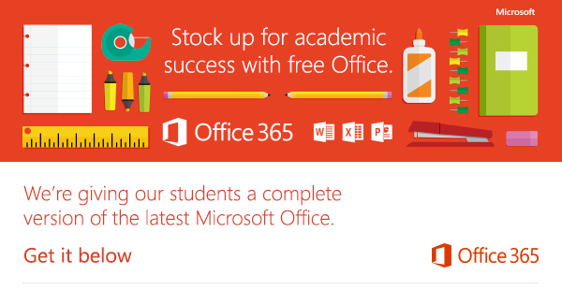
Instructions for installing Microsoft Office at home

In order to help our students prepare for success this school year, we’re providing Office to every student free of charge. With Office 365, your child will now have access to the latest version of Word, for writing; Excel, for spreadsheets; PowerPoint, for presentations; OneNote, for organization and note taking; and much more.

- Install on up to 5 compatible PCs and Macs, plus 5 tablets (including iPad!)
- Use with OneDrive for automatic device syncing
- Gain valuable skills by using Microsoft’s productivity software
- Office subscription lasts for as long as your child is a student in the district

Instruct your child to follow these simple steps to get their “Office”:
- For PC and Mac:
  - Visit Office.com/GetOffice365
  - Click through to install and follow the onscreen process
  - On the installation page select your language and click install
- For iOS and Android:
  - Download from your device’s app store
  - Sign in with your school credentials for full editing capability

Your child will need their school email account information to sign in. Student email addresses are in the following format, firstname.lastname@sdirc.org. The username is their email address and the password is the same password they use to login to the computers at school. If you have trouble, please contact your child’s school.

