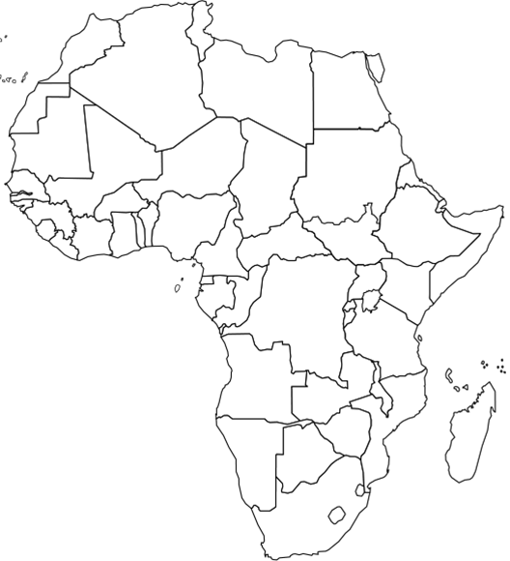

Europe

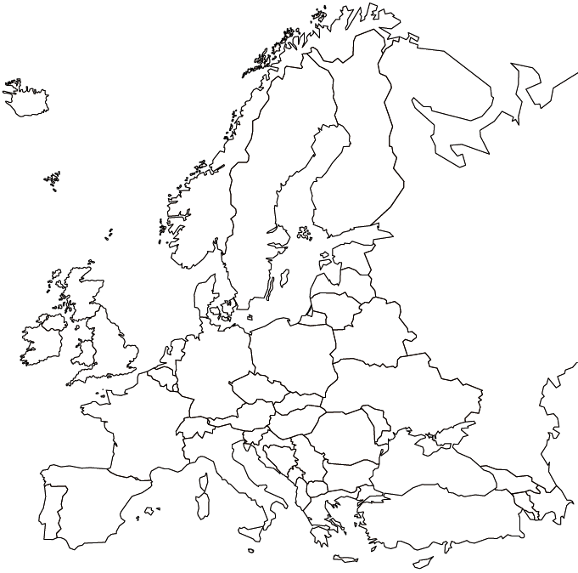

South America
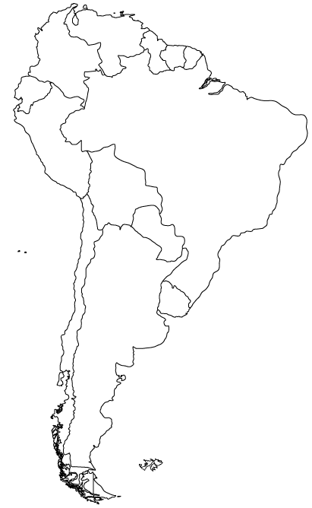
LABEL: Brazil, Argentina, Chile, Peru, Colombia, Venezuela, Bolivia, Equador
NORTH AMERICA

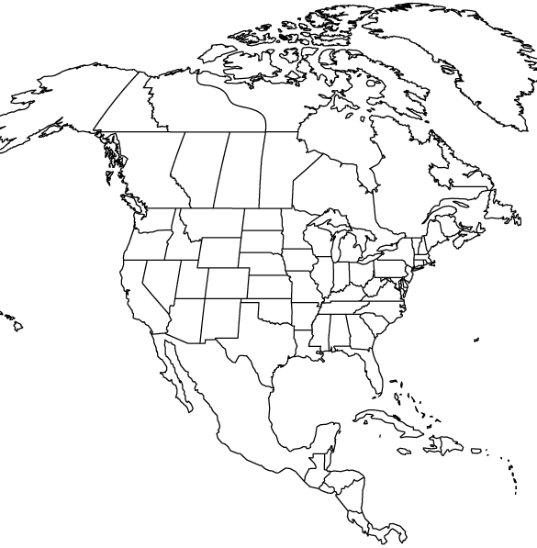

LABEL: Canada, US, Mexico, Cuba, Haiti, Jamaica, Belize, Panama, Honduras, Costa Rica, Guatamela, El Salvador & Nicaragua
ASIA

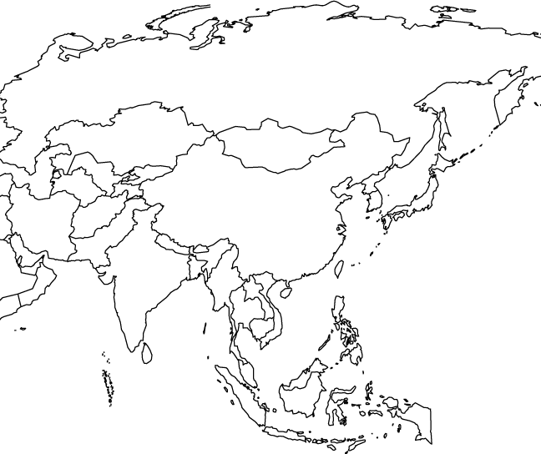

Label: India, China, Japan, Philippines, Mongolia, Nepal, Mayanmar, Malaysia, Indonesia, Vietnam, North Korea, S. Korea

MIDDLE EAST

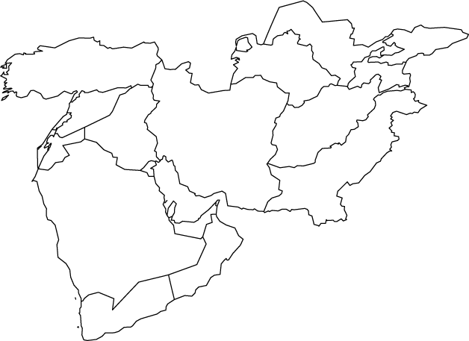

Label All

