Chapter 7 Document Analysis

CAUSE AND EFFECT TEMPLATE

EVENT: The Second Great Awakening spreads in the 1820s and 30s.

CAUSES

1. What was the most direct or immediate cause of the event (i.e. a violent act, a
discovery, a specific law, etc.?

2. Were there also any indirect causes of the event like broad economic, political, social,
or philosophical changes? Explain.

3. Did any people or groups of people either cause the event or change the outcome
of the event? Explain.

EFFECTS

4. What kind of changes in government and/or economics occurred (or you think might
occur) as a result of this event?

5. Were there any social consequences for this event (i.e. changes in daily living, religion,
or technology (new inventions or the manner in which people lived their lives)?

6. Explain how these changes (from questions #4 and 5) impacted or will impact history?

LOUISIANA PURCHASE

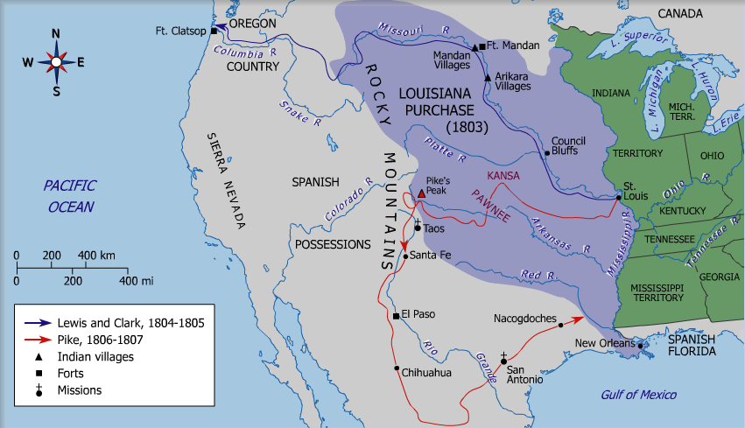

Questions:

- What consequences did the Louisiana Purchase have on American politics? (Consider struggles between parties, the question over states’ rights, international relations, native American relations, etc.)
- What purposes (other than exploration) did the Lewis and Clark expedition serve?

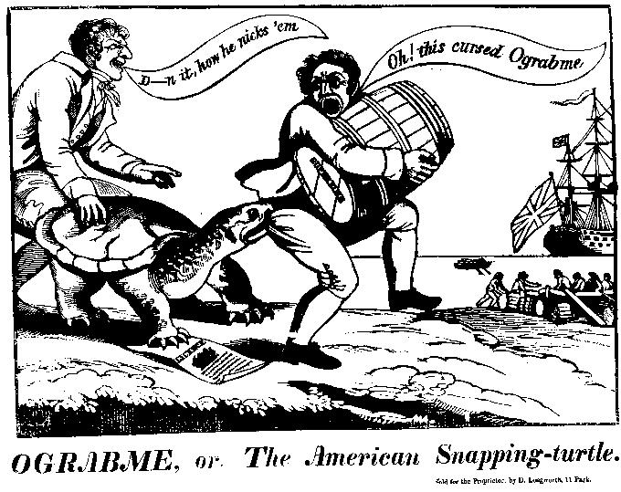

The cartoon above refers to the Embargo (ograbme, spell it backwards) Act of 1807. Answer the questions below.

- What were the economic impacts of the issue? Who supported it and who opposed?

- What were the political impacts of the issue? Who supported it and who opposed?

- What is the cartoon trying to say? Is it pro- or anti-Embargo Act?

