**CHAPTER 4 DOCUMENT ANALYSIS**

**4.1: MAP SKILLS: French and Indian War**



**4.2 APPARTY**

Complete an APPARTY on the following document

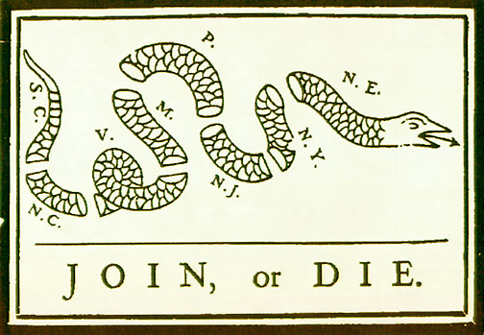

**4.3: WAR ANALYSIS**

**War: French and Indian War**

|  |  |
| --- | --- |
| Were there any military/civilian advantages/disadvantages before or during the war? | Who were the major civilian and military leaders? |
| Side A:  Side B: | Side A civilian:  Side A Military:  Side B Civilian:  Side B Military: |
| What were the causes of the war? | Were there any turning point battles? |
| Short term:  Long Term: |  |
| What were the long and short term strategies to win the war? | What were the costs of the war? |
| Side A:  Side B: | Side A  Political:  Social:  Economic:  Side B:  Political:  Social:  Economic: |
| Non-Treaty Results (How did the war itself or its aftermath affect participants and/or non-participants?) | How did the treaty ending the war affect participants and/or non-participants? |
|  | Name of treaty:  Date:  Terms: |

**4.4: ACTS ANALYSIS**

|  |  |  |
| --- | --- | --- |
| **ACT**  **(Define after colon)** | **CROWN’S REASONING FOR THE ACT** | **WHY IT PUSHED COLONISTS TOWARD REVOLUTION** |
| **Proclamation of 1763:** |  |  |
| **Sugar Act:** |  |  |
| **Currency Act:** |  |  |
| **Stamp Act:** |  |  |
| **Declaratory Act:** |  |  |
| **Townshend Acts:** |  |  |
| **Tea Act:** |  |  |
| **Intolerable Acts:** |  |  |