Chapter 11 Doc Analysis

Nat Turner, The Confession of Nat Turner (1831)
In 1831 Nat Turner, a literate slave who had gained a considerable following among the slaves in Virginia, led an insurrection of slaves against their masters. Fifty-five whites were killed in the revolt, and at least that many African Americans were killed in immediate and delayed retaliation. The slave owners suspected a much wider conspiracy, however, and they responded with increasingly restrictive legal codes to prevent another uprising. Turner addressed his confession, which is excerpted below, to his white lawyer, Thomas R. Gray.

. . . To a mind like mine, restless, inquisitive and observant of every thing that was passing, it is easy to suppose that religion was the subject to which it would be directed, and although this subject principally occupied my thoughts-there was nothing that I saw or heard of to which my attention was not directed-The manner in which I learned to read and write, not only had great influence on my own mind, as I acquired it with the most perfect ease, so much so, that I have no recollection whatever of learning the alphabet-but to the astonishment of the family, one day, when a book was shewn to me to keep me from crying, I began spelling the names of different objects-this was a source of wonder to all in the neighborhood, particularly the blacks-and this learning was constantly improved at all opportunities-when I got large enough to go to work, while employed, I was reflecting on many things that would present themselves to my imagination, and whenever an opportunity occurred of looking at a book, when the school children were getting their lessons, I would find many things that the fertility of my own imagination had depicted to me before. . . .
[A]ll my time, not devoted to my master's service, was spent either in prayer, or in making experiments in casting different things in moulds made of earth, in attempting to make paper, gun-powder, and many other experiments, that although I could not perfect, yet convinced me of its practicability if I had the means.
I was not addicted to stealing in my youth, nor have ever been-Yet such was the confidence of the negroes in the neighborhood, even at this early period of my life, in my superior judgment, that they would often carry me with them when they were going on any roguery, to plan for them. Growing up among them, with this confidence in my superior judgment, and when this, in their opinions, was perfected by Divine inspiration, from the circumstances already alluded to in my infancy, and which belief was ever afterwards zealously inculcated by the austerity of my life and manners, which became the subject of remark by white and black.
Having soon discovered to be great, I must appear so, and therefore studiously avoided mixing in society, and wrapped myself in mystery, devoting my time to fasting and prayer-by this time, having arrived to man's estate, and hearing the scriptures commented on at meetings, I was struck with that particular passage which says: "Seek ye the kingdom of Heaven and all things shall be added unto you." I reflected much on this passage, and prayed daily for light on this subject-As I was praying one day at my plough, the spirit spoke to me, saying "Seek ye the kingdom of Heaven and all things shall be added unto you."
Question-what do you mean by the Spirit? Ans.-The Spirit that spoke to the prophets in former days-and I was greatly astonished, and for two years prayed continually, whenever my duty would permit-and then again I had the same revelation, which fully confirmed me in the impression that I was ordained for some great purpose in the hands of the Almighty.
Several years rolled round, in which many events occurred to strengthen me in this my belief. At this time I reverted in my mind to the remarks made of me in my childhood, and the things that had been shewn me-and as it had been said of me in my childhood by those by whom I had been taught to pray, both white and black, and in whom I had the greatest confidence, that I had too much sense to be raised, and if I was, I would never be of any use to any one as a slave. Now finding I had arrived to man's estate, and was a slave, and these revelations being made known to me, I began to direct my attention to this great object, to fulfill the purpose for which, by this time, I felt assured I was intended.
Knowing the influence I had obtained over the minds of my fellow servants (not by the means of conjuring and such like tricks-for to them I always spoke of such things with contempt) but by the communion of the Spirit whose revelations I often communicated to them, and they believed and said my wisdom came from God. I now began to prepare them for my purpose, by telling them something was about to happen that would terminate in fulfilling the great promise that had been made to me- . . . .

Document Analysis
- Who is the intended audience?
- What is the purpose of the document?
- What is the historical context of the document (what’s going on in the larger scheme of things)?
- What is the author’s point of view?

Nat Turner Rebellion, 1831
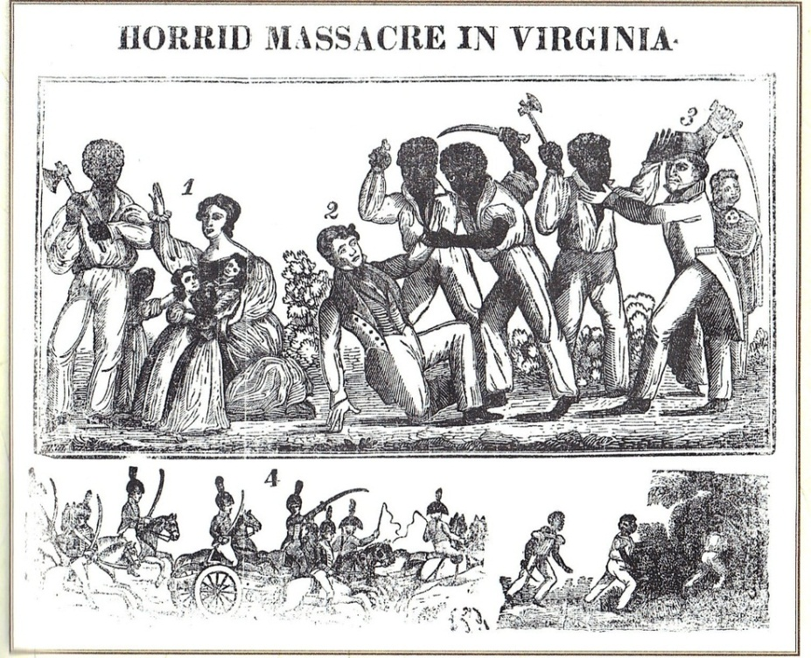
In 1831, Nat Turner led the most famous slave uprising in U.S. history in Southampton County, Virginia. During the uprising 55 white people were killed, and as many black people were killed in the aftermath before Turner was apprehended and executed. (Library of Congress)

Thought Questions
- Revolt was one reaction of slaves to their condition. Nevertheless, large-scale slave revolts were rare and never succeeded. Why?
- What were other, more common reactions of slaves to their condition

Mathew Carey, “Rules for Husbands and Wives,” (1830)
- Irish-born Mathew Carey eventually settled in Philadelphia, where he became a publisher, bookseller, and economist, with a special fondness for universal education. His Miscellaneous Essays included the excerpt below, which outlined what he believed to be proper behavior between married persons. The United States was changing in the early 1830s, as recorded by Alexis de Tocqueville in Democracy in America. This period was marked by economic growth, westward expansion, expanding international and domestic markets, and scientific progress. It was also during this period that the anti-slavery movement was gaining momentum, and from within that movement would emerge the women’s rights movement. Carey’s essay is one example of an early reconsideration of proper gender roles in American society.

- Having seen various sets of maxims for the conduct of married life, which have appeared to me to contain some very injudicious items, degrading to wives, sinking them below the rank they ought to occupy, and reducing them in some degree to the level of mere housekeepers, and believing them radically erroneous, I annex a set which appear more rational and just than most of those which I have seen:
- 1. A good husband will always regard his wife as his equal; treat her with kindness, respect and attention; and never address her with an air of authority, as if she were, as some husbands appear to regard their wives, a mere housekeeper.
- 2. He will never interfere in her domestic concerns, hiring servants, &c.
- 3. He will always keep her liberally supplied with money for furnishing his table in a style proportioned to his means, and for the purchase of dress suitable to her station in life.
- 4. He will cheerfully and promptly comply with all her reasonable requests, when it can be done, without loss, or great inconvenience.
- 5. He will never allow himself to lose his temper towards her, by indifferent cookery, or irregularity in the hours of meals, or any other mismanagement of her servants, knowing the difficulty of making them do their duty.
- 6. If she have prudence and good sense, he will consult her on all great operations, involving the risque of ruin, or serious injury in case of failure. Many a man has been rescued from destruction by the wise counsels of his wife. Many a foolish husband has most seriously injured himself and family by the rejection of the advice of his wife, fearing, lest, if he followed it, he would be regarded as ruled by her! A husband can never procure a counsellor more deeply interested in his welfare than his wife.
- 7. If distressed, or embarrassed in his circumstances, he will communicate his situation to her with candour, that she may bear his difficulties in mind, in her expenditures. Women sometimes, believing their husband's circumstances to be far better than they really are, expend money which cannot well be afforded, and which, if they knew their real situation, they would shrink from expending.
- 1. A good wife will always receive her husband with smiles,--leave nothing undone to render home agreeable--and gratefully reciprocate his kindness and attention.
- 2. She will study to discover means to gratify his inclinations, in regard to food and cookery; in the management of her family; in her dress, manners and deportment.
- 3. She will never attempt to rule, or appear to rule her husband. Such conduct degrades husbands--and wives always partake largely of the degradation of their husbands.
- 4. She will, in every thing reasonable, comply with his wishes--and, as far as possible, anticipate them.
- 5. She will avoid all altercations or arguments leading to ill-humour--and more especially before company.
- 6. She will never attempt to interfere in his business, unless he ask her advice or counsel, and will never attempt to control him in the management of it.
- Should differences arise between husband and wife, the contest ought to be, not who will display the most spirit, but who will make the first advances. There is scarcely a more prolific source of unhappiness in the married state, than this "spirit," the legitimate offspring of pride and want of feeling.
- Perhaps the whole art of happiness in the married state, might be compressed into these two maxims--"Bear and forbear"--and "let the husband treat his wife, and the wife treat her husband with as much respect and attention, as he would a strange lady, and she a strange gentleman." And surely this is not an extravagant requisition.

Analysis Questions
- Who is the intended audience?
- What is the purpose of the document?
- What is the historical context of the document (what’s going on in the larger scheme of things)?
- What is the author’s point of view?

