Population Density Maps

Directions: Study the chart below and answer the questions that follow.

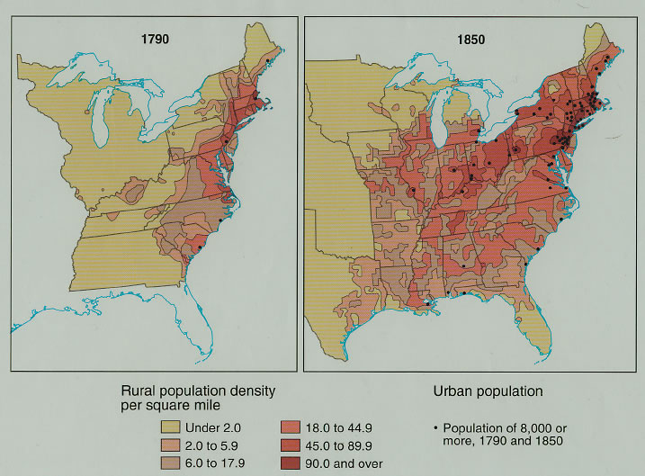

- By 1850, centers of high population density were concentrated in what area of the United States?
- Economically, why is this trend significant?
- In 1790, populations were most dense along the eastern seaboard. What inventions in the early 1800s allowed population centers to move further west and along the Great Lakes?
For what reason(s) did southern population density remain low in 1850?

CAUSE AND EFFECT TEMPLATE

EVENT: Chief Justice John Marshall supports a strong federal government in the
epochal McCulloch v. Maryland case.

CAUSES

1. What was the most direct or immediate cause of the event (i.e. a violent act, a
discovery, a specific law, etc.?

2. Were there also any indirect causes of the event like broad economic, political, social,
or philosophical changes? Explain.

3. Did any people or groups of people either cause the event or change the outcome
of the event? Explain.

EFFECTS

4. What kind of changes in government and/or economics occurred (or you think might
occur) as a result of this event?

5. Were there any social consequences for this event (i.e. changes in daily living, religion,
or technology (new inventions or the manner in which people lived their lives)?

6. Explain how these changes (from questions #4 and 5) impacted or will impact history?

ELECTION ANALYSIS

Election Year: 1824

Candidate:
Party Affiliation:
Popular Vote:
Electoral Vote:
Campaign Platform:
Winner:
Significant Domestic Events During Term |  | Significant International Events During Term

Election Year: 1828

Candidate:
Party Affiliation:
Popular Vote:
Electoral Vote:
Campaign Platform:
Winner:
Significant Domestic Events During Term |  | Significant International Events During Term

