Chapter 5 Document Analysis

“We hold these truths to be self-evident, that all men are created equal, that they are endowed by their Creator with certain unalienable Rights, that among these are Life, Liberty and the pursuit of Happiness. — That to secure these rights, Governments are instituted among Men, deriving their just powers from the consent of the governed, — That whenever any Form of Government becomes destructive of these ends, it is the Right of the People to alter or to abolish it, and to institute new Government, laying its foundation on such principles and organizing its powers in such form, as to them shall seem most likely to effect their Safety and Happiness.”
Part One – Declaration of Independence

- Describe the main circumstances that led our nation’s founders to write the Declaration of Independence.
- Identify how this quote, in the minds of the patriots, justified their actions. Where did these rights the author speaks of come from?
- Identify the immediate effect of the publishing of the Declaration of Independence. Explain how the British reaction to this action may have increased or decreased tensions and the inevitability of the coming war.

APPARTS
DOCUMENT ANALYSIS

Complete an APPARTS on the following document: Guide on next page

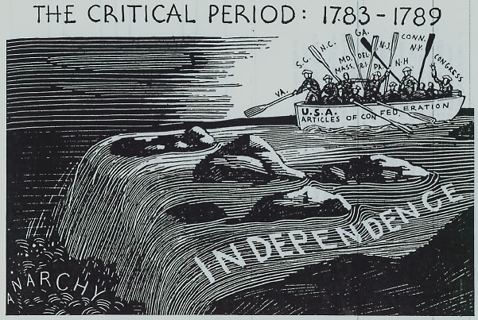
APUSH Social

Women's Rights and The Revolution

When John Adams was serving in the Continental Congress, he corresponded regularly with his wife, Abigail:

Abigail to John
I long to hear that you have declared independency- and, by the way, in the new code of laws, which I suppose it will be necessary for you to make, I desire you would Remember the Ladies, be more generous and favorable to them than your ancestors. Do not pit such unlimit6ed power in to the hands of Husbands. Remember all men would be Tyrants if they could. If particular care is not paid to Ladies, we are determined to foment a Revolution, and we will not hold ourselves bound by any laws in which we have no voice or representation. That your sex are naturally tyrannical is a truth so thoroughly established as to admit of no dispute. But such of you as wish to be happy willingly give up the harsh title of master for the more tender and endearing one of friend. Why, then, not put it out of the power of the vicious and the lawless to use us with cruelty and indignity..? Men of sense in all ages abhor those customs which treat us only as the vassals of your sex. Regard us then as beings, placed by providence under your protection, and in imitation of the Supreme Being make use of that power only for our happiness. [Letter from Abigail Adams to John Adams, March 31, 1776]

John to Abigail
. . . As to your extraordinary code of laws, I cannot but laugh. We have been told that our struggle has loosened the bands of government everywhere. . . . Depend upon it, we know better than to repeal our masculine systems. Although they are in full force, you know they are little more than theory. We dare not exert our power in its full latitude. We are obliged to go fair and softly, and in practice, you know, we are the subjects.
We have only the name of master, and rather than give up this, which would completely subject us to the despotism of the petticoat, I hope General Washington, and all our brave heroes would fight. I am sure every good politician would plot, as long as he would against despotism, empire, monarchy, aristocracy, oligarchy, or ochlocracy – a fine story indeed. [Letter from John Adams to Abigail Adams, April 14, 1776]

- What does this exchange of letters tell you about the status of women in revolutionary America?
- Why do you think the founding fathers were hesitant about extending political equality to women in 1776?
- Name three ways in which you think the position of women has changed, for better or worse, since colonial days.

APUSH Ch. 5 Battle of Saratoga

CAUSE AND EFFECT TEMPLATE

EVENT: American general, Benedict Arnold, defeats the British at the Battle of Saratoga in 1777.

CAUSES

1. What was the most direct or immediate cause of the event (i.e. a violent act, a
discovery, a specific law, etc.?

2. Were there also any indirect causes of the event like broad economic, political, social, or philosophical changes? Explain.

3. Did any people or groups of people either cause the event or change the outcome
of the event? Explain.

EFFECTS

4. What kind of changes in government and/or economics occurred (or you think might occur) as a result of this event?

5. Were there any social consequences for this event (i.e. changes in daily living, religion, or technology (new inventions or the manner in which people lived their lives)?

6. Explain how these changes (from questions #4 and 5) impacted or will impact history?

EVENT: Daniel Shays leads a revolution in 1785 against Massachusetts’ tax policies.

CAUSES

1. What was the most direct or immediate cause of the event (i.e. a violent act, a
discovery, a specific law, etc.?

2. Were there also any indirect causes of the event like broad economic, political, social,
or philosophical changes? Explain.

3. Did any people or groups of people either cause the event or change the outcome
of the event? Explain.

EFFECTS

4. What kind of changes in government and/or economics occurred (or you think might
occur) as a result of this event?

5. Were there any social consequences for this event (i.e. changes in daily living, religion,
or technology (new inventions or the manner in which people lived their lives)?

6. Explain how these changes (from questions #4 and 5) impacted or will impact history?

