COMPARING 2ND VS. 3RD WAVE IMMIGRANTS
 | 2ND WAVE (1800-1860) | 3RD WAVE (1860-1940)
Countries of Origin

Reason for immigration

Education level

Economic status upon arrival

Assimilation effort

From How the Other Half Lives, Jacob Riis
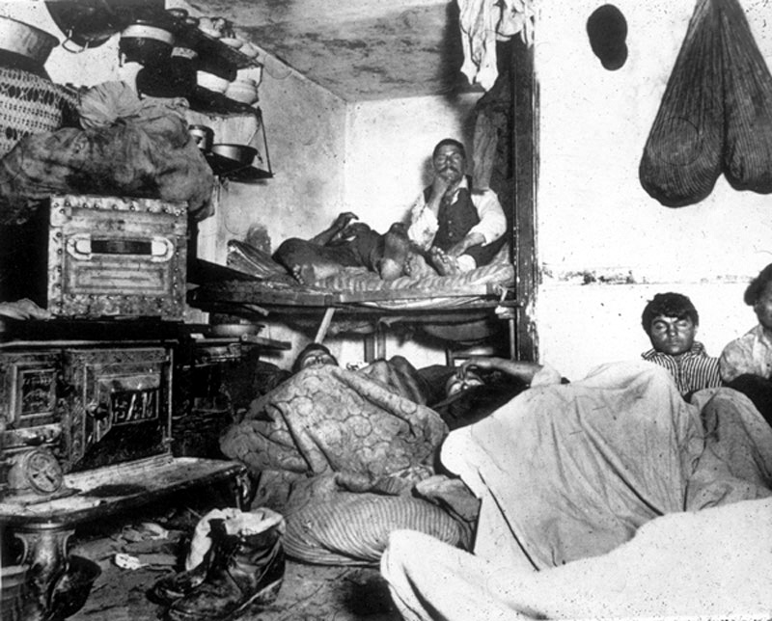
Analysis Questions
- What inferences can you make about the people in this photograph?
- What is their level of material existence?
- What does this tell you?

